

**Assignment#2**

**Lab of fundamental programming**

**Submitted by: Muhammad Yahya Chand**

**ROLL#: 456727**

**Section: ME-15B**

**Date: 11oct,2023.**

**Task#1:**

#include<iostream>

#include<cmath>

using namespace std;

int main(){

int x;

cin>>x;

if(90<=x&&x>=100){

cout<<"your grade is A";

}

else if(75<=x&&90>x){

cout<<"your grade is B";

}

else if(60<=x&&75>x){

cout<<"your grade is C";

}

else if(45<=x&&60>x){

cout<<"your grade is D";

}

else{

cout<<"your grade is E";

}

return 0;

}

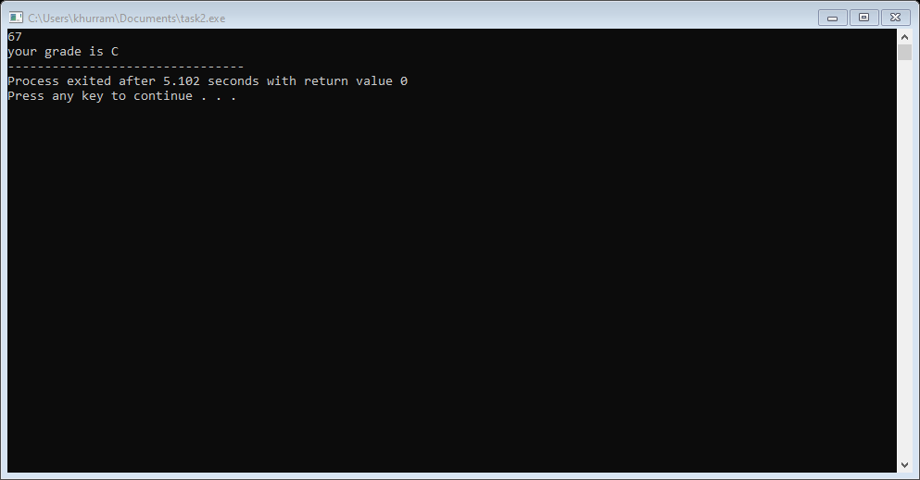

**Task#2:**

#include<iostream>

using namespace std;

int main(){

int i;

cout<<“please enter the integer: ”;

cin>>i;

if(i/2&&i/5){

cout<<“the integer is divisible by 2 and 5”;

}

else{

cout<<“your integer is not divisible by 2 and 5”;

}

return 0;}

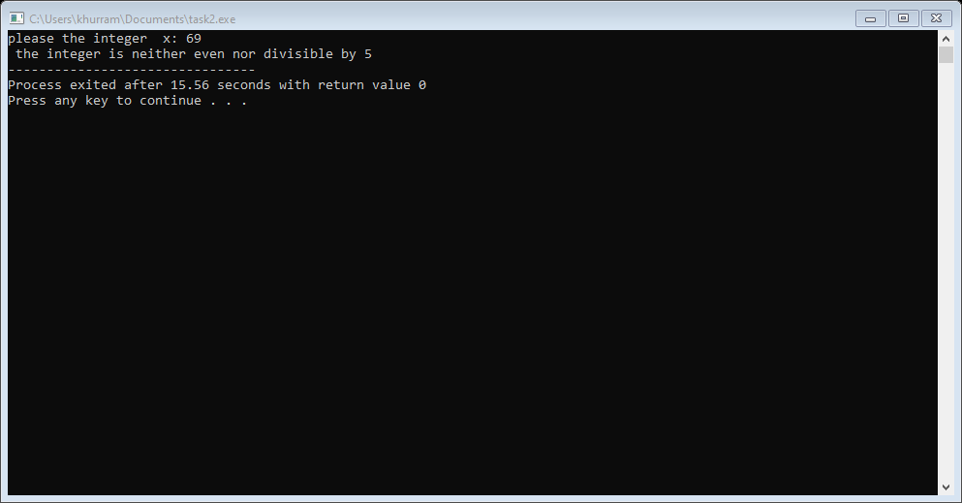

**Task#3:**

#include<iostream>

#include<cmath>

using namespace std;

int main(){

int a;

cout<< "please enter the year: ";

cin>>a;

if( a%4==0 && a%100!=0){

cout<< " this year is a leap year";}

else {cout<<" this year is not a leap year";}

return 0;}

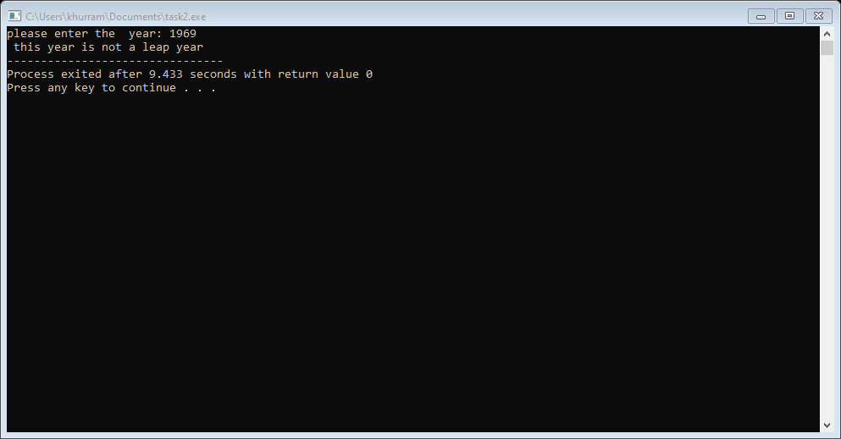

**Task#4:**

#include<iostream>

#include<cmath>

using namespce std;

int main(){

float x;

float y;

cout<<" please enter the GPA: ";

cin>> x;

cout<< " please enter the attendance percentage: ";

cin>> y;

if( x>= 3.5 && y>=80){ {

cout<<"the student is eligible for scholarship";}

else { cout<<"the student is not eligible for scholarship"; }

return 0; }

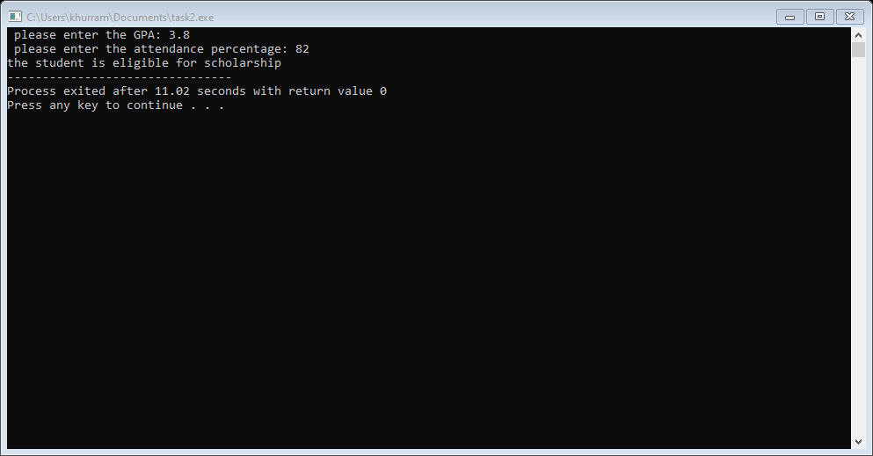

**Task#5:**

#include<iostream>

#include<cmath>

using namespace std;

int main(){

char x;

cout<< "please enter the character: ";

cin>>x;

if ( x=='a'||x=='e'||x=='i'||x=='o'||x=='u'){

cout<< " the entered character is a vowel";}

else { cout<< " the entered character is a consonant";}

return 0;}

